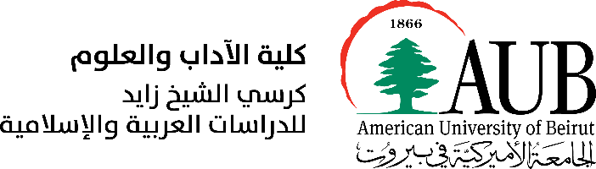 [logo](http://oriental-studies.org.ua/)

**CALL FOR PAPERS**

International Academic Conference

“Ahatanhel Krymskyi and Lebanon”

On the occasion of the 150th anniversary of Ahatanhel Krymskyi, the Embassy of Ukraine in the Lebanese Republic, the Department of Arabic and Near Eastern Languages at the American University of Beirut (AUB), the Sheikh Zayed Chair for Arabic and Islamic Studies at AUB, and the A. Krymskyi Institute of Oriental Studies of the National Academy of Sciences of Ukraine have the honour to invite you to an international academic conference “Ahatanhel Krymskyi and Lebanon” that will be held on June 8-9, 2021 in an all-online format.

[Dates subject to change due to the current health situation.]

Ahatanhel Krymskyi (1871-1942) was a Ukrainian scholar in Middle Eastern studies, a linguist, folklorist, translator, and polyglot, as well as one of the founders of the National Academy of Sciences of Ukraine and the pioneer of Near and Middle Eastern studies in Ukraine. In 1896-1898, Krymskyi lived in Lebanon and Syria where he studied the Arabic language and Islam and gathered a rich collection of documents and materials about this region of the Ottoman Empire, its traditions, customs, and life stories. His scholarly and epistolary heritage includes a significant number of works on the history, literature, and culture of Lebanon, Syria, Turkey, Iran; reviews on Abyssinian literature; studies on semitology, history of Islam, and history of Ukrainian literature and language, folklore, and ethnography. He translated from Arabic, Persian, Turkish (Antara, Al-Maarri, Jami, Saadi, Omar Khayyam, Hafez, Ferdowsi, Khalifa Ziya) as well as from European languages into Ukrainian. In 1970, the 16th session of the UNESCO General Assembly added his name to the list of prominent global figures.

His time in Lebanon occupies a special place in Ahatanhel Krymskyi’s biography as it was his first personal encounter with the Arab World. He stayed mainly in Beirut and Shweir, lived in a Lebanese family, actively studied the Arabic language and its colloquial varieties. He worked at manuscript repositories and libraries and wrote for Arabic periodicals and newspapers including the Al-Machriq journal. Krymskyi witnessed the life of Lebanese people in the Ottoman Empire at the end of XIX century, during the Arab Nahda. Indeed, this experience in Lebanon greatly inspired his works, as he went on to write the Beirut cycle of poems titled “Palm tree branches”, and his correspondence with his relatives about life in Lebanon provided a basis for “Beirut Stories” book.

This conference aims to bring to light Ahatanhel Krymskyi’s works as a part of Lebanese history within the context of the Ottoman Empire and the Arab Nahda, and as a common page in Ukrainian-Lebanese relations. Therefore, we are particularly interested in papers that explore the following topics:

* Ahatanhel Krymskyi as a founder of the East-European academic school of Middle East Studies.
* Krymskyi in Lebanon (1896–1898): sites, trips, social environment.
* “Beirut Stories” and “Palm tree branches” by A. Krymskyi.
* Krymskyi as a researcher of Lebanese history, everyday life, and colloquial Arabic at the end of XIX century.
* Krymskyi’s contribution to the Middle East studies: Classical and Modern Arabic Literature, Islam and Sufism, History of Arabic Language, etc.
* Krymskyi’s as a translator of the Arabic and Persian classical literature.

Papers related to Krymskyi’s contribution to other fields of Middle Eastern Studies will be accepted too.

Working languages: Arabic, English, French.

Hosts of the Conference are planning to publish an electronic version of the collection of abstracts (Book of Abstracts) of the participants in May 2021. Please send the abstract (up to 400 words, double-spaced) including your full name, complete affiliation and position, and your CV by May 10 to [oip00@mail.aub.edu](mailto:oip00@mail.aub.edu). Full papers of the participants will be included in the Book of Proceeding which will be published after the conference. The full articles (up to 24 pages including references) should be submitted by September 30, 2021.

For inquiries, please contact Ms. Oksana Prokhorovych at [oip00@mail.aub.edu](mailto:oip00@mail.aub.edu).

Organizing Committee: Bilal Orfali, Maryna Hrymych, Oksana Prokhorovych, Oleksandr Bohomolov, Danylo Radivilov.